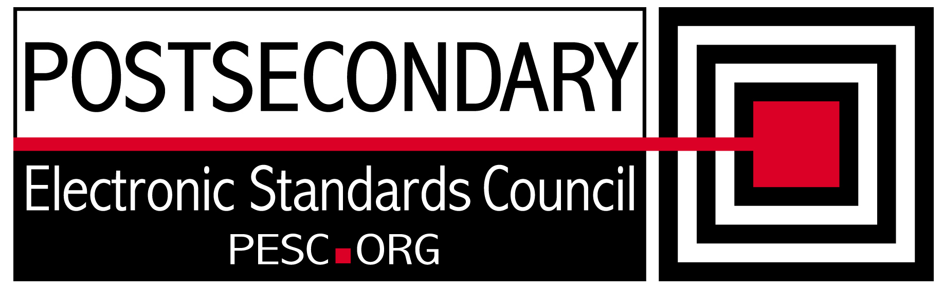

Standards Forum for Education
Status Update Form

Workgroup/Board/Group Name: | Technical Advisory Board
General Summary of Status: | Completed the kick off meeting with the new co-chairs and had Steve and Michael Sessa introduce the issues that need to be resolved. Developed a measurement tool for schemas
Status Flag (Red, Yellow, or Green): | Green
Report Date: | 7/8/10
Projected Completion Date: | Standing Board
Item | Responsible Resource | Status
Planned Deliverables/Objectives:  - Component Architecture Approach  - Technical Approach to incorporation of CDS | Team, Kumar Shunmuhan  Team | Awaiting Report on R&R enhancements  Clarifying objectives
Accomplishments/Completions:
- Developed java tool to examine memory and processing time metrics for schema and instance document load
- Introduced new co-chairs to team
Issues/Obstacles:
- None Yet

Assistance Needed:

Chair(s)/Leader(s) Name(s): | Gideon Sanstra, Michael Morris
Meetings/Calls Since Last Update: | 3

Note: Chairs and/or leaders of workgroups, boards and committees under The Standards Forum for Education are required to provide updates during the Steering Committee’s monthly conference call meeting held the second Friday each month at 2:00pm EST. Call in information is: 866-352-3799 *7696363*. Forms must be completed and submitted prior to meeting time. Forms may also be posted on the PESC website as needed to provide the community at-large with a means to obtain updates for ongoing, but yet to-be-completed development efforts.

